Man 3D Prints His Own Hodgkin’s Lymphoma Cancer Tumors Prior to And After Chemotherapy

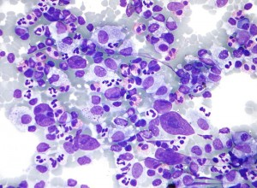
One of the scariest things that anyone can hear coming from their doctor’s mouth are the following three words: “You have cancer.” Instantly panic begins to set in, and dozens of questions begin manifesting much quicker than they can be answered. For one man, named Mark (last name will remain anonymous), these are the words that came from the mouth of a specialist he had gone to visit, after suffering from terrible spells of itching.
“The only symptom I had leading up to the diagnosis was constant chronic itching which is sometimes a symptom of lymphoma,” Mark told 3DPrint.com. “If you’ve ever had poison ivy, the itching was comparable to that, minus the rash. The doctors had been trying to figure it out for several months before I finally got to a specialist who suspected it and gave me a chest X-ray.”
Upon examining the chest x-ray, doctors found a 14cm Hodgkin’s Lymphoma tumor in Mark’s chest. While cancer can be quite scary, Mark was given a pretty good prognosis, but he would need to go through chemotherapy and radiation treatments, in order to help shrink the tumor as much as possible. “At the time I was diagnosed, I had just started in a new position at (a) university, and didn’t want to let the cancer define who I was, so I didn’t really tell too many people other than close friends,” Mark told us. “I was actually able to make it through chemo with very few people knowing.”
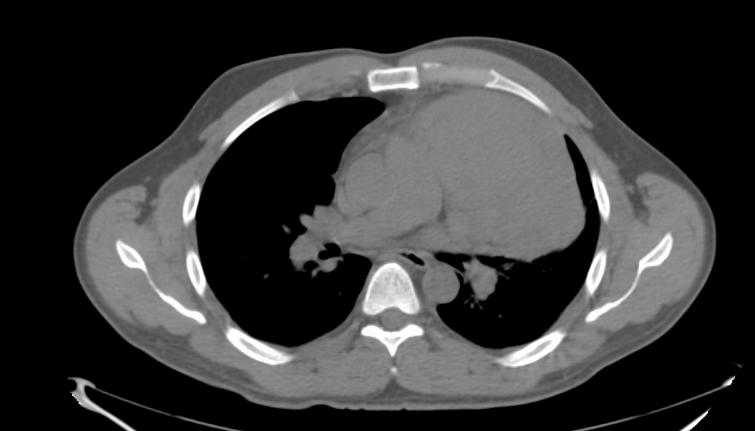
Image showing Mark’s tumor collapsing part of his lung.
A couple of faculty at the university that Mark worked at had just received a grant to purchase a MakerBot 2 and MakerBot 2X 3D printer, so that they could print out molecules to be used as teaching aids for pharmacy students. Mark came up with the brilliant idea of using his illness to learn about 3D printing, as well as teach others about the technology.
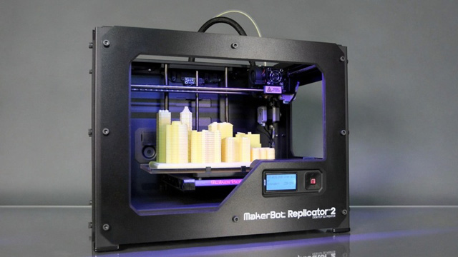
MakerBot Replictor 2
“I had seen a few news articles about researchers 3D printing anatomy, so I thought printing my tumor would be a great way to learn the software and workflow while at the same time creating a model that could potentially be used in some of our courses – there was probably a little bit of it being a way to reassure myself that I was getting better mixed in,” Mark explained.
Mark decided to contact his doctors and was provided with CDs containing his first PET/CT scan, as well as his post chemotherapy CT. He then downloaded a software called Slicer, which many of those familiar with 3D printing use quite often. It allowed him to directly import and open the CT scans, and then create a 3D printable STL file from them. “Basically the process was to go through each slice of the CT and trace around the tumor,” explained Mark. “It was a fairly time consuming process and fairly difficult because I have no real experience viewing CT scans, so sometimes it was hard to distinguish tumor from important things such as my heart.”
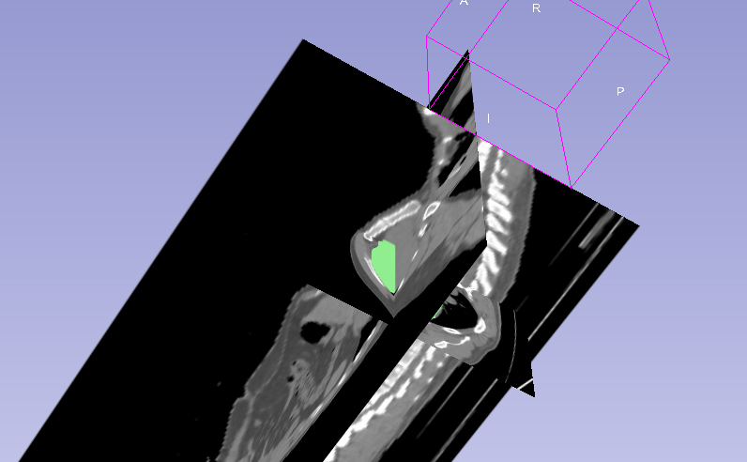
Mark imported the DICOM files from my CT into Slicer, and created a digital model of the tumor by tracing around each slice of the CT
Once finished, Mark sent the print off to the MakerBot 3D printer, and then came back 5 hours later to check on it. When he came back, it was only about half way complete. “That was about the point in time it hit me as to how large this thing inside me had been,” he said. “The doctors had told me measurements and I had pulled out a ruler and looked. I knew it was big, but actually seeing it sitting there was still a shock.”
When the first print had finished, Mark decided to also print out his post-chemotherapy tumor — the one that had shrunk tremendously through treatment. 3D printing allowed Mark to get a realistic view of not only how large the tumor had been, but also how much it had shrunk. “It was really cool seeing how the chemo worked, he explained. “I could hold them to my chest and get a feel for how big it had been and how big it was now.”
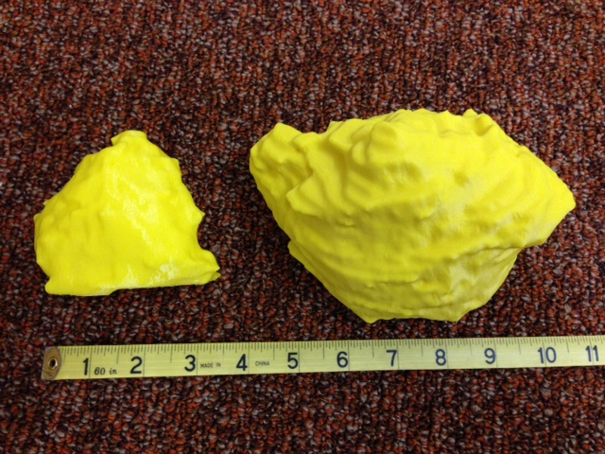
Post-chemo tumor on left, and pre-chemo tumor on right. – 3D printed on a MakerBot 3D Printer.
Mark then took the finished prints into work, to show some of his colleagues who do cancer research and teach classes on oncology and chemotherapeutic agents. They absolutely loved them and ask Mark for a set of their own that they could use in class as visual aids. Yet another faculty member at the University also wanted a set in order to help teach a course on diagnostic imaging, and allow students to compare Mark’s CT scans to the tangible 3D printed models.
All of Mark’s doctors were very enthusiastic when he showed his 3D printed tumors to them as well. All in all, Mark ended up making at least 4 separate copies to hand out to his doctors and radiologists.
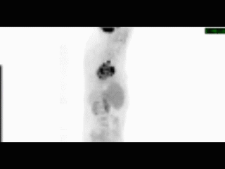
PET/CT of Mark’s Tumor (depicted in black).
As for Mark, he is doing just fine. Luckily there is a 70-90% cure rate for Hodgkin’s Lymphoma. He is currently done with his chemotherapy and radiation treatments and is in a “wait and see” stage right now. If he goes 5 years without a relapse, he will be considered cured of the disease.
Mark is thoroughly impressed with 3D printing. He sees it having a tremendous future in education. “I think right now, there’s a huge opportunity for using 3D printing this way for education,” he told us. “The faculty I work with are brilliant and come up with great ideas for it all the time. Right now, our printers are working overtime printing mock syringe shields and pigs (leaded containers for holding radioactive vials). These are devices used for shielding pharmacists from radiation while they’re preparing doses of radiopharmaceuticals. A real syringe shield costs about $500 and a real pig costs about $400. We’re going to see if students can be taught proper dose drawing technique prior to working with the real equipment. Students will be able to take home the 3d printed versions and practice technique before coming to lab.”
Personally I think every radiologist should have a 3D printer on hand to help patients as well as doctors better understand the size and location of tumors, prior to and after chemotherapy and radiation treatments. The technology has so much potential within the medical field, it still astonishes me how little it is being used within most medical practices.
What do you think about Mark’s 3D printed tumors? Do you think more doctors and radiologists should be using this technology for patients? Discuss in the 3D Printed Tumor forum thread on 3DPB.com.

